Nama : Muhammad Hanif Aji Wiratama

NIM :18090065

Kelas : 5B

**PRAKTIKUM 3**

1. Source Code

Matakuliah.php-> application/controller

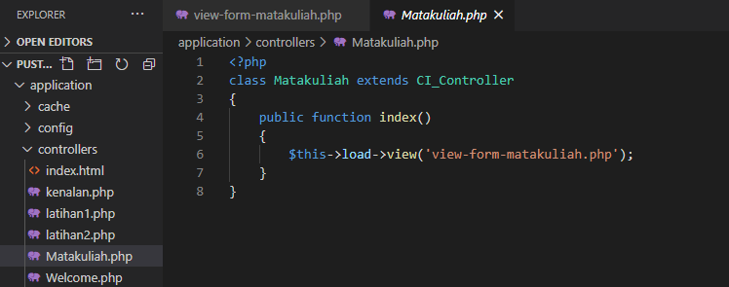

View-form-matakuliah.php->application/view

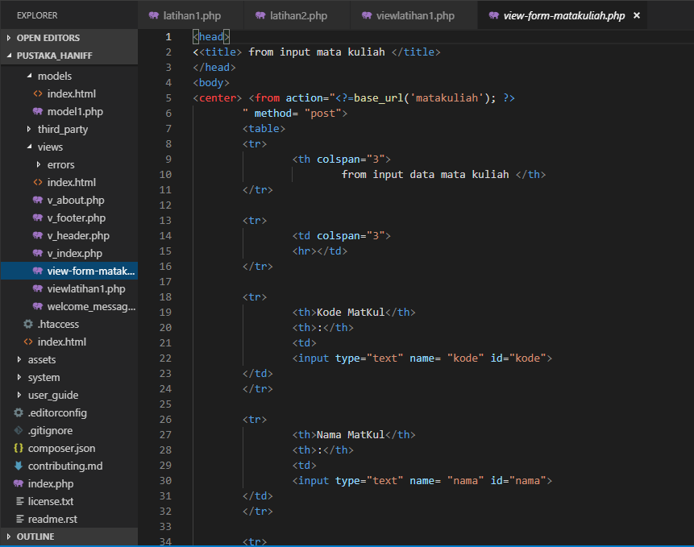

1. URL

[http://localhost/pustaka_haniff/index.php/Matakuliah](http://localhost:8090/pustaka_haniff/index.php/Matakuliah)

1. Capture Hasil

